**Experiment No: 03**

**Name of the Experiment:** Study of False Position Method to Obtain the Root(s) of a Nonlinear Equation.

**Objectives:** The objective of this experiment is to apply false position method to find out the very precise value of the root of an equation, using MATLAB.

**Theory:** If the function *f*(*x*) is continuous in [*a, b*] and *f*(*a*)*f*(*b*) *<* 0 (i.e. the function *f* has values with different signs at *a* and *b*), then a value *c ∈* (*a, b*) exists such that *f*(*c*) = 0[1].

The false position algorithm attempts to locate the value c where the plot of *f* crosses over zero, by checking whether it belongs to either of the two sub-intervals [a,c],[c,b],where c is the midpoint  
c=[a*f(b)- b*f(a)]/[ f(b)- f(a)]

**Tool:** MATLAB Software

**Methodology:**

**(I) Algorithm:** Step 1: Choose lower *a* and upper *b* guesses for the root such that the function changes sign over the interval. This can be checked by ensuring that *f*(*a*)*f*(*b*) < 0.  
Step2 : An estimate of the root *c* is determined by c=[a*f(b)- b*f(a)]/[ f(b)- f(a)]  
Step 3: Make the following evaluations to determine in which subinterval the root lies:  
(*a*) If *f*(*a*)*f*(*c*) < 0, the root lies in the lower subinterval. Therefore, set *b* = *c* and return to step 2.  
(*b*) If *f*(*a*)*f*(*c*) > 0, the root lies in the upper subinterval. Therefore, set *a* = *c* and return to step 2.  
(*c*) If *f*(*a*)*f*(*c*) = 0, the root equals *c*; terminate the computation.[4 chap]

**(II)Flowchart:**

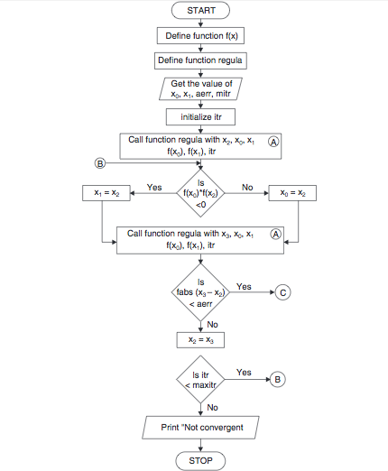

**Figure 2.1 Flowchart of bisection method procedure [2]**

**(III) MATLAB Code:** The given function is f(x) =2x^2-15x+3

y= @(x) 2*x^2-15*x+3 ;

while(1)

a=input('Enter the value of 1st assumption:');

b=input('Enter the value of 2nd assumption:');

if y(a)*y(b)>0

fprintf('WRONG!!\n');

elseif y(a)*y(b)<0

break;

end

end

if y(a)==0

fprintf('Root')

return

elseif y(b)==0;

fprintf('Root')

return

end

display(' No. a b c y')

display('---- ----- ----- ----- -----')

for i=1:1:100

c=(a*y(b)-b*y(a))/(y(b)-y(a));

if y(a)*y(c)>0

a=c;

else b=c;

end

if abs(y(c))<.0001

break;

end

fprintf('%d %f %f %f %f \n',i,a,b,c,y(c));

datatables=table(a,b,c,y(c));

end

**Output:**

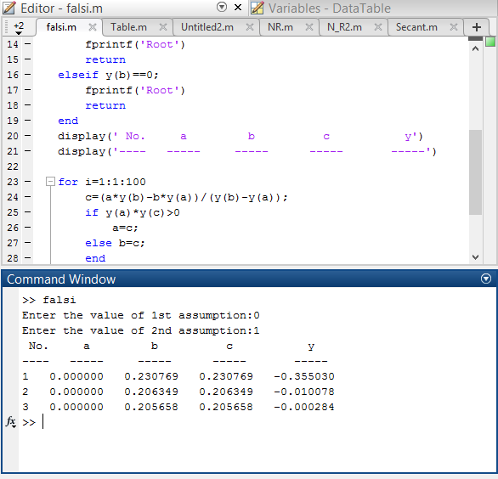

**Result& Discussion:** The roots of the given function is 0.205688.Which is nearly close to the original value (0.205638) direct calculated by calculator.

**Conclusion:** So from the above test we saw that nearly 3rd iteration we get the resultant value of two roots which is very close to the original roots.

**References:**

[1]C. Chapra and P. Canale Raymond , “*Numerical Methods for Engineers”,* 7th ed. McGraw-Hill Education, 2 Penn Plaza, New York, NY 10121, 2015

[2]*Regula Falsi Method Algorithm and Flowchart,*CODEWITHC, April 21, 2014.Accessed on: Jan. 23,2020[online].

Available:<https://www.codewithc.com/regula-falsi-method-algorithm-flowchart/>